**RESUME**

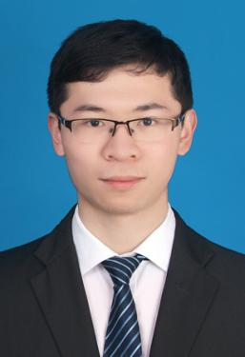

(+31)639816389

wujianwei618@gmail.com

Hoofddorp, Netherlands

**Professional Skills**

* Skilled in C programming; familiar with Java,Python, Shell scripting; adept at reading and understanding assembly language.
* Proficient in working with Linux-based embedded operating systems.
* Networking Knowledge: Well-versed in the principles of TCP, UDP, and HTTP protocols; experienced in utilizing network communication interfaces for data transmission and reception.
* Familiar with Linux, Windows and Android program design; able to develop debugging and testing programs.
* Language : Native Mandarin Speaker. Fluent English in oral communication(TOEIC 805). French (A2）

Jianwei Wu

**WORK EXPERIENCE**

**08/2023-present BYD EUROPE B.V., Hoofddorp, Netherlands Senior Software Engineer**

**07/2021-08/2023 Xpeng Automobile Technology Co., Ltd, Guangzhou, China Embedded Software Engineer**

**05/2020-03/2021 Huawei, Paris, France Terminal Test Engineer**

**ABOUT ME**

* Strong passion for embedded development, with a keen interest in contributing to innovative projects.
* Deep interest in digital products, including PCs, mobile phones, and IoT devices.
* Enjoy swimming, running, and fitness, with a love for exploring nature and traveling.
* Passionate about learning new languages and broadening cultural horizons.

**EDUCATION**

**09/2018-10/2020 Institut supérieur d'électronique de Paris(ISEP) Master/Engineer in Embedded Systems**

Courses: Computer Fundamentals and Linux, Computer Networking, ARM, Digital Signal Processing

**09/2014-06/2018 Chongqing University Of Posts And Telecommunications Bachelor in Microelectronics Science**

Courses: C Program Language, Digital circuits, Microelectronics, Semiconductor Manufacturing, CMOSRF, EDA, FPGA

**Project Experience**

**Over-the-Air (OTA) Application Development for Overseas Platforms Time Period: [2024.6-now]**

* Developed and maintained the OTA front-end application using Java on the Android Automotive platform.
* Designed UI/UX components tailored to the in-vehicle environment, including update status displays
* Technologies Used: Java, Android Automotive, OTA Frameworks, UI/UX Design, In-Vehicle Infotainment (IVI) Systems.

**Development for TBox Systems Time Period: [2021.7-2023.7]**

* Participated in the development of TBox systems for multiple vehicle models, ensuring seamless integration and functionality.
* Managed issue resolution, progress tracking, software integration, and version releases.
* Technologies Used: Shell, GIT, Makefile

**Linux Device Driver Development Time Period: [2021.11-2022.6]**

* Debugged and developed audio drivers, including codec and operational amplifier configurations, with a strong familiarity with ALSA audio driver architecture and its implementation.
* Resolved technical issues related to audio performance and device functionality.
* Technologies Used: Linux Kernel, Device Tree, Audio Drivers, Codec.